10/20/2025
Sedgewick, Jacob
Rolsa Technologies
How to reduce your carbon Footprint

Table of Contents
Contents
Table of Contents 1
Business Context 2
Client Brief Review 2
Stakeholders 2
Constraints 2
Empathy Mapping 2
SWOT analysis 3
User stories and acceptance 3
Functional and Non-Functional Requirements 5
Functional Requirements 5
Non-Functional Requirements 5
Decomposition of Requirements 6
KPIs & User Acceptance 7
Proposed Solution 7
Justification 8
Meet the client and user needs 8
Risks, mitigation & wider issues 8
Regulatory Guidelines and legal requirements 9
Appendix 10

Business Context

Client Brief Review
The client would like us to develop a digital solution that will provide customers with green energy products currently on the market and how to recue their carbon footprint. They have also asked us for their customers to be able to schedule consultations with carbon footprint experts which will help them reduce their carbon footprint and the solution should also let them calculate their carbon footprint which will allow them to see how they are affecting the environment with their current usage. Once completed this will provide automated suggestions based of research (see Appendix A 2 and 3) on how they can make their life more environmentally friendly.

Stakeholders
Internal – CEO, Board of directors, Employees,
External - People interested in calculating their carbon footprint, Customers, Companies supplying green products

Constraints
Our system would have to have a very low carbon footprint and be environmentally friendly which may impact the systems performance as it would take up less CPU.
Another constraint would be that we would be judged heavily on our environmental impact and how if we store data and other information efficiently

Empathy Mapping
John - Doesn’t care about the environment but want to switch to cleaner energy choices as it is cheaper in the long run
Says  Complains to people he knows about energy prices | Thinks  Cleaner energy such as solar panels, Hydro and wind are cheaper
Does  Uses our system and switches to our recommendation of cheap clean energy | Feels  Ripped off by the energy prices he is paying currently with natural gas

Emma – Cares deeply about client change and want to help the plant become a cleaner place to live
Says  Tells her friends she needs to become better with her carbon footprint | Thinks  My carbon footprint is to high I need to get it down
Does  Downloads our app and gets recommendations on how to reduce her carbon footprint | Feels  Disappointed with her carbon footprint but is determined to get it better

SWOT analysis
S – Strengths  Will allow people to have a better carbon footprint  Will help improve climate change  Will allow people to speak to experts on how they can improve their climate footprint | W – Weakness  Will have to constantly research to keep giving the best advice  Will need to make sure app is environmentally friendly
O – Opportunities  Government may help with the app and give us money due to the intentions of the app | T – Threats  May be a target for hackers as we will hold personal information due to users being able to create an account.

User stories and acceptance
Person 1
Name – John Smith
Age – 32
Gender – Male
Occupation – Works for a construction company as a plumber
Education Level – Level 3 in pluming
Goals – Wants to have a cheaper energy bill
Challenges – Doesn’t care about environment
Behaviours and Attitudes – Uses a manual car, doesn’t care about environment, spends time on apps which take up a lot of CPUS

Person 2
Name – Emma Johnson
Age – 22
Gender – Female
Occupation – Part time job at McDonalds
Education Level – Studying Economics at Manchester Uni in 3rd Year
Goals – Wants to have a better carbon footprint
Challenges – Doesn’t have much money so is limited on her choices
Behaviours and Attitudes – Determined to become better environmentally
As a … | I want | So That | Acceptance Criteria
Customer | Speak to consultants, book installations and get advice on my carbon footprint | I can improve my carbon footprint and reduce prices | The user should be able to book schedules, book installations, be given advice on their carbon footprint and see their carbon footprint to try and help improve the environment
Consultant | Speak to my clients and give them advice | I can help them have a better carbon footprint and help the plant become a better place to live | The consultant should be able to see all their appointments, cancel them edit them and interact with users outside of video calls

Functional and Non-Functional Requirements

Functional Requirements
  - Provides customers with green energy products in the market
The system should be able to provide customers with information about where they can buy green energy products it should automatically filter it by the cheapest to help give the customers the best results
  - Helps users reduce their carbon footprint
The system should give users tips on how they can reduce their carbon footprint and do it by giving them the most cost-effective way.
  - Schedule Consultations
The system should allow users to book consultations about how they can improve their carbon footprint with green energy experts which can give them expert tips and advice
  - Calculate their carbon footprint
The system should allow users to calculate their carbon footprint and then it should suggest quick and easy ways of getting their carbon footprint down by deleting app that are bad etc.

Non-Functional Requirements
  - Security
The system should be secure and follow all laws and regulations to ensure the full trust of our customers
  - Maintenance
The system should be easily maintained we can do this by adding comments frequently that are short and explain what our code does and use functions as this will translate to the user experience as the system will run better and enable a better user experience
  - Performance
The app should have good performance and should be able to switch pages or tabs in under 5 seconds. This will help the user experience and will make the customer enjoy our app.

Decomposition of Requirements
Scheduling Appointments
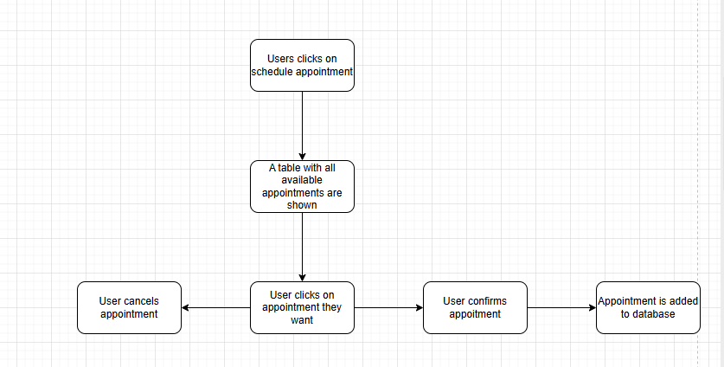
Log in/ Security
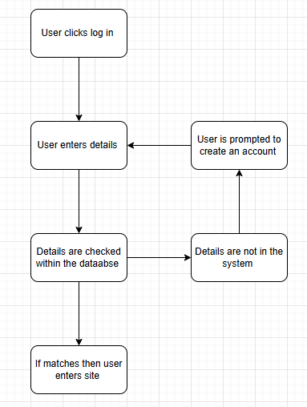

KPIs & User Acceptance
  - Number of links clicked on to buy products
If customers are clicking on the links suggested by the system, then the suggestions are relevant and useful to the customers however, if customers are not clicking on the links to go and buy the products then the suggestion are not relevant enough and the system would need to be updated so that the user gets useful recommendations. If users feel the app is not being useful enough then they will start deleting the app or not using it.
  - Percentage of people improving their carbon footprint who use the app
When people first join the app, they will be asked to do a carbon footprint test where we will calculate their carbon footprint, after this they will be giving recommendations of how they can reduce their carbon footprint and become better sustainably. Every month we will ask them to do another carbon footprint test so that we can see if their carbon footprint is improving. If their carbon footprint gets better than the system is supplying clear and good recommendations and the system is working however, if the carbon footprint remains the same or goes down then the recommendations may not be clear enough or useful.
  - Number of consultants scheduled
We will track the amount of time that people use our expert consultant. If people are using them then we will add more and upgrade the system to make it easier for both the user and the consultant. However, if the feature is not used enough then we will remove the feature as this will help reduce our costs and increase the speed of the system improving the user experience.

Proposed Solution
Our proposed solution will allow the users to be able to search for the best green energy products on the market and provide them with cheapest places to get it both in-store and online. It will give tips to users on how to reduce their carbon footprint. It will also allow users to be able to schedule consultations with experts and installations for products such as solar panels and wind energy. The system will also allow users to calculate their carbon footprint and then give them recommendation to help the reduce it.

Justification

Meet the client and user needs
The system meets both the clients and users’ needs as the system meets all the requirements of the clients brief which allows users to be able to search for green energy products, reduce their carbon footprint, calculate their carbon footprint and schedule consultations. The system will have a user-friendly UI which will be easy to navigate. The performance of the app will allow users to switch pages within 5 seconds which will make the app easy and efficient to use. I believe that there would be a high demand for this system (see Appendix B 1,2,3)

Risks, mitigation & wider issues
Risk | Impact Level | Likelihood | Mitigation Plan | Contingency Plan
User data is leaked | High | Not likely | We would shut the servers down and notify all users telling them to change all their passwords etc. | We will have both a physical and cloud server and will follow all laws and regulations and will protect all our data using firewalls and VPNs
Laws and regulations aren’t followed | Extremely High | Very Unlikely | Follow all laws and regulations | We will follow all laws and regulations
Cloud server goes down | High | Somewhat likely | We will have a physical server in our office where we are able to run basic features while the servers are down | We also have a physical server which would run only performing basic features while we fix the cloud server.
Physical server goes down | Low | Somewhat Likely | We will use the cloud server | Will use cloud server and will also make sure only authorised people have access to the physical server by using role-based access

Regulatory Guidelines and legal requirements
Item | Description
GDPR Compliance | Data in encrypted and users are consenting to how we user their data
Accessibility | Interface meets WCAG 2.1 standards
Ethical use of data | No tracking without permission from user
Fair access | No discrimination in system design
ESG Compliance | Following all laws, regulations, and industry standards regarding environmental impact, social responsibility, and corporate governance
ISO 14001 | An international standard for environmental management systems
Uk Environment Act 2021 | requires developments to ensure habitats are left in a measurably better state, driving demand for nature-based solutions and green infrastructure.

Appendix
Appendix A
- Usage in carbon footprint apps is significantly increasing with apps such as Too Good to Go and Olio having millions of downloads
- 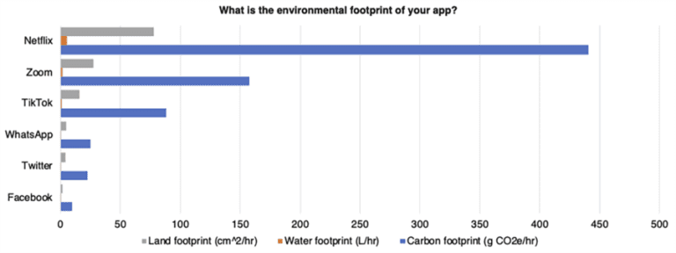
- New tech such as Sustainable agriculture, electric vehicles and solar
- 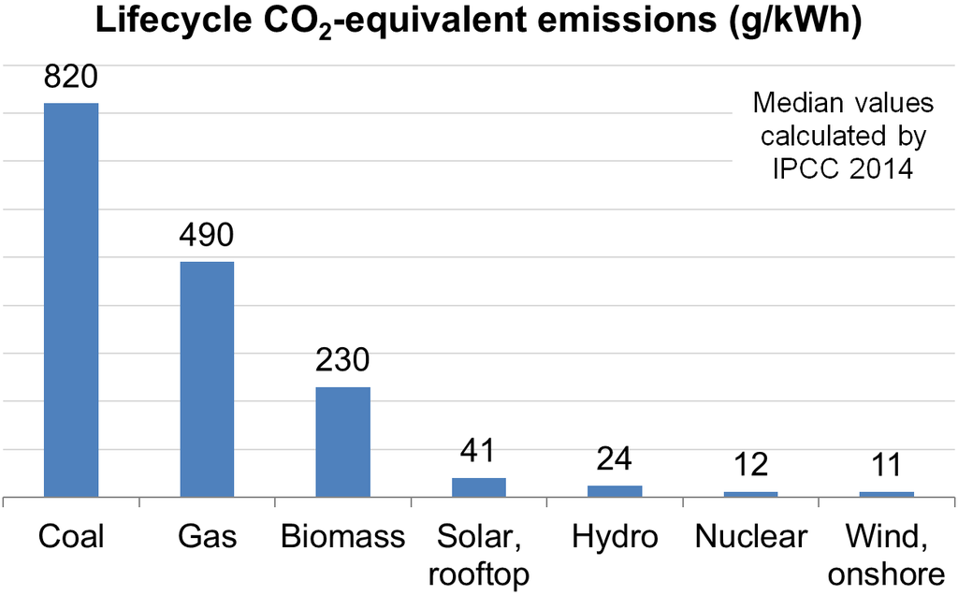
- 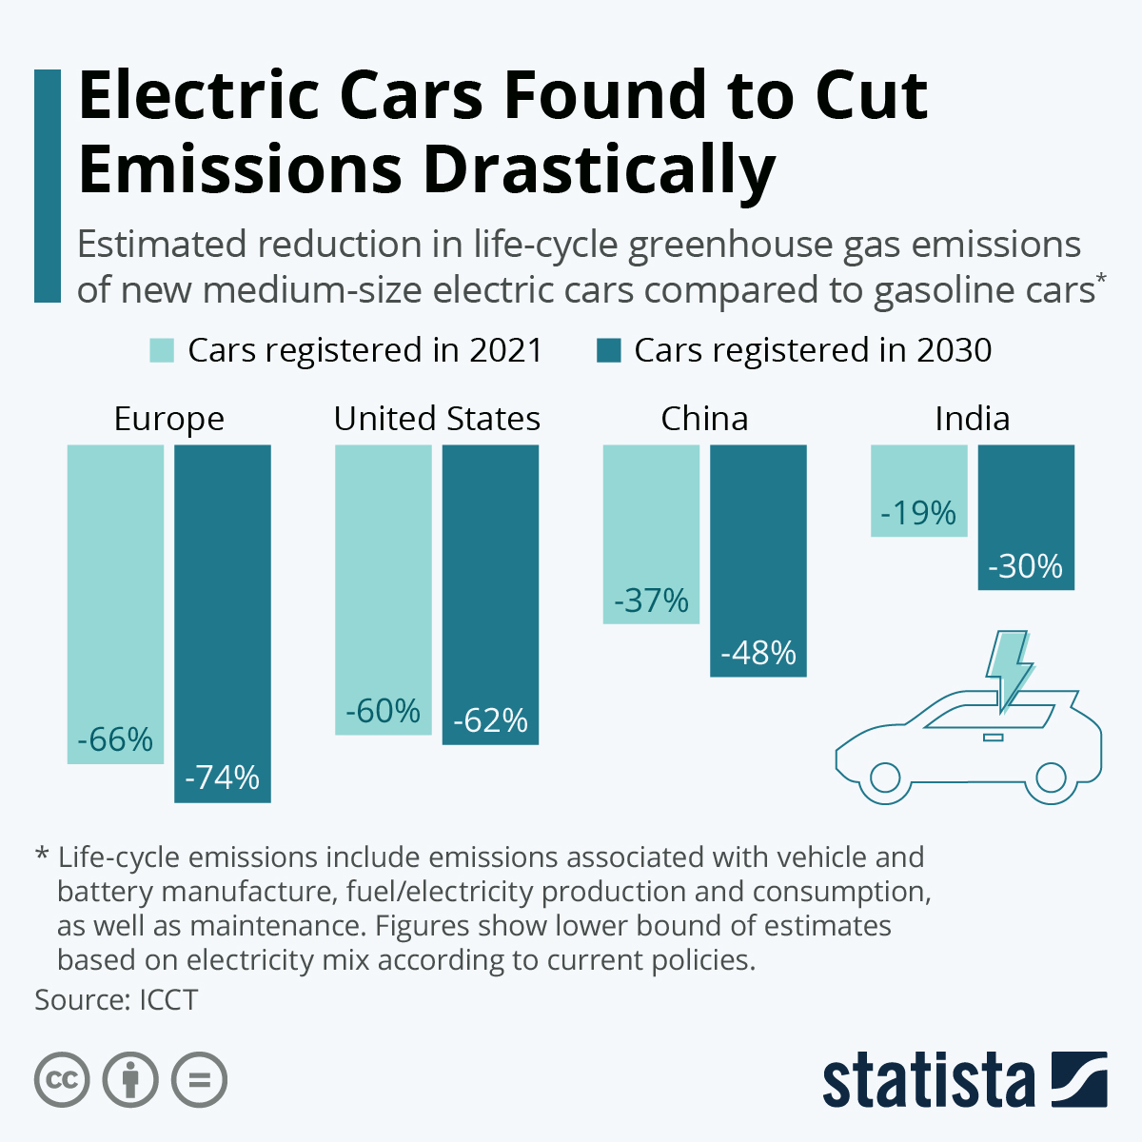

Appendix B
- Demand for sustainable support:
88% of consumers want brands to help them live more sustainably, according to a Forbes article.
- Climate change concern:
In 2023, 83% of Americans and 90% of people in the UK agreed that climate change is a serious threat.
3. Brand trust:
92% of global consumers say they trust brands that are socially and environmentally responsible.
4. 27% of greenhouse gas emissions come from transport - United States Environmental Protection Agency
5. Half of London’s air pollution comes from road transport - Mayor of London

